Week 1 session 5
1 Squares of sorted array
class Solution {
public int[] sortedSquares(int[] nums) {
int[] result = new int[nums.length];
for (int i = 0; i < nums.length; i++) {
result[i] = nums[i] * nums[i];
}
java.util.Arrays.sort(result);
return result;
}
}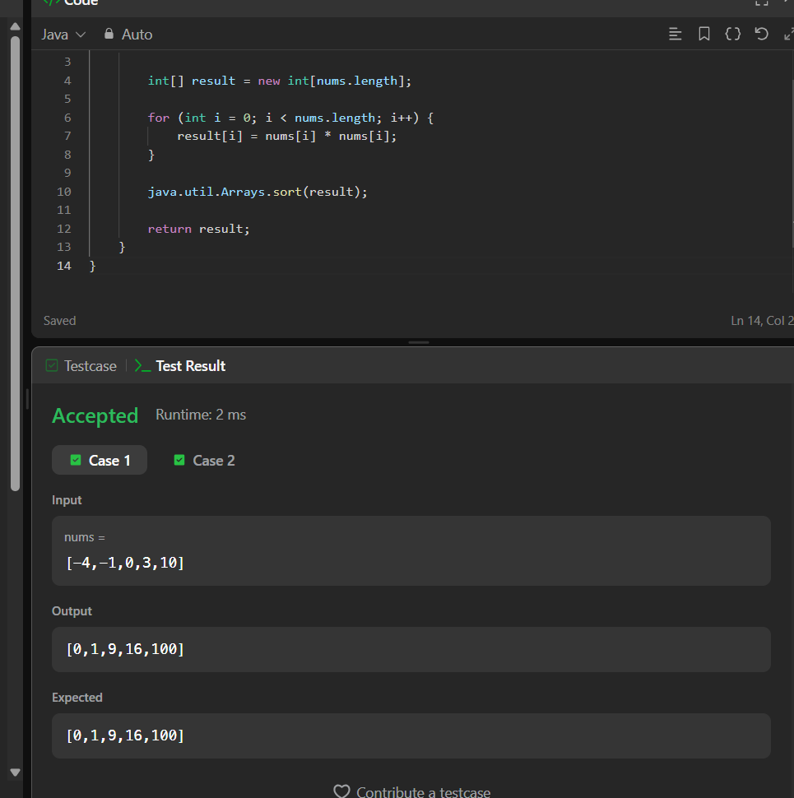
2.find pivot element
class Solution {
public int pivotIndex(int[] nums) {

int total = 0;

for (int num : nums) {
total += num;
}

int leftSum = 0;

for (int i = 0; i < nums.length; i++) {

int rightSum = total - leftSum - nums[i];

if (leftSum == rightSum) {
return i;
}

leftSum += nums[i];
}

return -1;
}
}